From: http://davidstockmanscontracorner.com/keynesian-central-bankers-the-useful-idiots-of-bubble-finance-part-2/
Feb 5, 7, & 8. Search" "Useful Idiots of Bubble Finance"

"The idiocy of r*" "The idiocy of rstar" rstar

Keynesian Central Bankers---The Useful Idiots Of Bubble Finance, Part 2
By David Stockman. Posted On Thursday, February 7th, 2019
The chart monkeys slipped off the ledge today after their determined run to tag the 200-DMA on the S&P 500, thereby getting back to relative safety.
As is evident below, it has been a nearly vertical climb from the December 24 interim low of 2350 to today's close at 2704.
Then again, what stands out is the 13 month round trip since January 3, 2018 when today's close level was first reached, and the self-evident fact that the vast swings in-between bear no relationship whatsoever to the incoming data from the main street economy.
The latter has been weak for years, and there was no real underlying acceleration last year---save for short-lived boosts to headline GDP owing to export pull-forwards occasioned by the Donald's Trade War and a one-time drawdown of consumer savings owing to Uncle Sam's credit card financed tax cut.
But as we have shown elsewhere, at month number #116 of the current so-called recovery, real GDP is up only 18% from its pre-crisis level of Q4 2007; and that compared to a gain of 48% at the same month #116 of the only other business cycle that has lasted this long---the tech and dotcom boom of the 1990s.
[?]Those contrasting figure for cumulative output gain over the cycle measure the weak part, and the non-acceleration part is this: [?] Real final sales (which remove the short-run distortions of inventory swings from the GDP figures) have grown at a 2.69% rate during Trump's first 7 quarters, which is statistically indistinguishable from the 2.54% rate during Obama's last 11 quarters.
To be sure, neither figure has anything to do with the merits of the occupants of the Oval Office---because neither have much relevance when it comes to the $20 trillion US economy. Those real final sales numbers reflect the late stages of an octogenarian business cycle that is running out of gas and facing intensifying headwinds from all points on the compass---domestic and international.
So the relevant economic information for discounting the price of equities is that long-term growth is evaporating, the business cycle is so old that it has "recession ahead" written all over its forehead, and the Trumpian cavalry has not ridden to the rescue dispensing some new form of economic Viagra.
Accordingly, the stock market was already vastly over-valued back in early January 2018 when it was trading at today's 2704 level. That's because 2018 GAAP earnings are now largely in, and they totaled $124 per share for the full year after adjustment for the one-time effect of the tax cut.
We insist that the appropriate PE multiple depends on
- the sustainable growth rate of earnings over time, and
- the point in the cycle at which earnings are being evaluated.
That is, a much higher PE multiple is warranted during the second year of a healthy post-recession recovery than in year 10 of a feeble business expansion that is now only 4 months from record old age.
Likewise, one-year growth rates are noise, not meaningful metrics. So on an apples-to-apples basis (i.e. same corporate tax rates), S&P 500 earnings of $124 per share in 2018 represented a mere 3.5% growth rate from the $85 per share level posted at the top of the last cycle in June 2007.
Needless to say, the implied PE multiple of 21.8X back in January 2018 against the actual 2018 result was not remotely warranted at a point in the cycle cheek-by-jowl with the next recession, and after the weakest peak-to-peak earnings growth rate (3.5%) in modern history.
And that's especially true because fully $30 per share of the $39 per share gain during the past 11 years was owing to reduced after-tax interest expense, not operating income gains. Since corporate debt actually soared from $6 trillion to $8.6 trillion during this same eleven year period, it is obvious that even the tepid growth in S&P 500 profits over the cycle was due to the Fed's unprecedented, but one time campaign of radical interest rate repression.
In this context, we use the term "one-time" for good reason. Even if the Fed equivocates or throws in the towel on QT and its balance sheet reduction and normalization campaign, the only direction for corporate rates is up or at best flat. It is inconceivable that the 50% reduction in the weighted average cost of corporate debt between 2007 and 2017 that generated $30 per share of S&P earnings gains can be replicated a second time.
Furthermore, much of the balance of the $39 per share growth was due to stock buybacks and shrinkage of the share count, but that was a pro-, one-time effect, as well. So the combination of drastically higher debt levels and rising interest rates will sharply undermine the rate of return math of stock buybacks going forward, meaning that there will be far less stock repurchases and shrinkage of the float in future years.
Nor can the end of the Fed-fueled stock buyback binge be underestimated. Since 2008, corporations bought back $4 trillion of stock, and thereby accounted--on the margin---for all of the increase in share purchases during the last 11 years.
Given these realities, it can be well and truly said that the gyrations shown in the chart before were pointless and evidence not of a changing or improving macroeconomic backdrop, but evince, instead, the thrashing about of chart monkeys trading technical moving averages, trend lines, Fibonacci levels and numerous other market internals.
That is to say, there was no basis in sustainable GAAP earnings trends or macroeconomic developments that warranted
- the starting point in early January 2018 (2704);
- the 9% gain to the September 20 peak (2940);
- the 20% drop to the Christmas Eve low (2350); or
- the dead-cat robo-machine driven 16% bounce to 2735 two days ago.
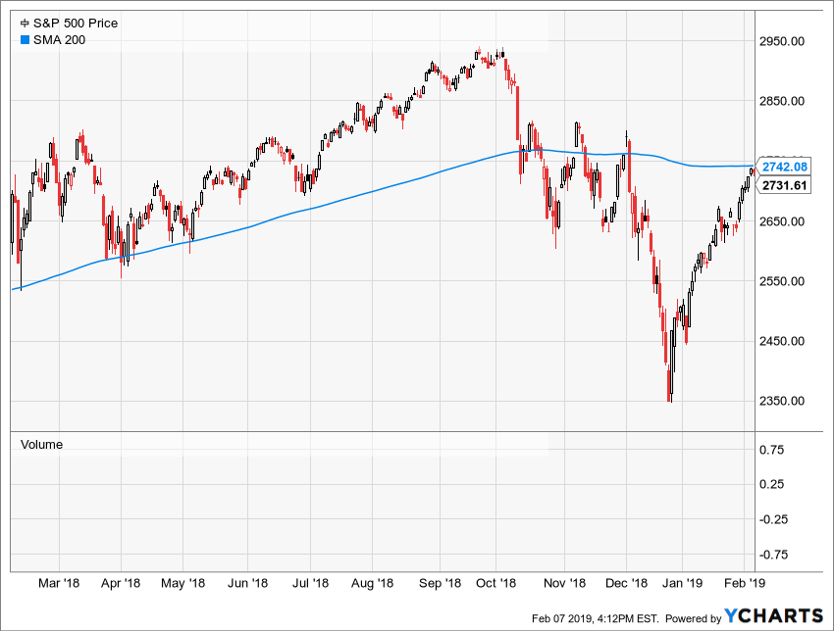
Needless to say, the chart monkey acrobatics shown above is not a form of harmless indoor sports enjoyed by the boys and girls domiciled in the Wall Street casino. To the contrary, the Fed has so completely broken the financial markets and eviscerated two-way trade and free market discipline that it has turned over the pricing of stocks and other financial assets to the incorrigible chart monkeys on display above.
To repurpose Jim Cramer's famous screed of August 2007 when the financial meltdown actually began, they know nothing!
That is, the combined algo and carbon trading herd shown above knows nothing about the real main street economy except fleeting headlines. Nor does it remotely grasp the import of changing government policy here and abroad or engage in the slightest manner in rational analysis of appropriate capitalization rates for earnings at variant points across the cycle and in the context of growing political and public policy instability.
Instead, they just mechanically buy that [sic] dips and read the word clouds emitted by the Fed and other central banks. And when the word clouds rain dovish, they hit the "buy" key and rationalize the reasons latter.
The problem with this is it leads to the accumulation of systemic instability in financial markets. Every time even a modest attempt at market correction incepts, the Fed's reaction function intervenes with dovish actions or braying, thereby causing the herd's dip-buying synapses to reactivate---as was so blatantly evident when Janet Yellen Powell capitulated after the Christmas Eve hissy fit.
At length, of course, Peak Irrational Exuberance is reached, a Black Swan unexpectedly appears and the herd stampedes into a meltdown modality that even the central bankers cannot arrest. That's what happened in April 2000 and September 2008, and what's looming just around the bend now---after the greatest bubble inflation ever.
So the question recurs. If the sum and substance of current Keynesian central banking is to create dangerous serial financial bubbles which crash and cause enormous damage to the main street economy through the C-suite panic and asset and jobs liquidation process (i.e. new style recessions) that we have described elsewhere, why do they keep doing it?
In a word, it's because they are blinded by a Keynesian bathtub model of the economy that is fundamentally obsolete and irrelevant in the current globalized system of open trade, capital and financial flows. As we indicated in Part 1, you can't measure potential output in a dynamic global economy, and there is not a snowball's chance in the hot place that tweaking the Federal funds rate or yield curve will enable the so-called output gap in the domestic economy to be closed.
Yet the erroneous idea of full-employment in one country is what undergirds current ZIRP and QE policy and what has caused the denizens of the San Francisco branch of the Fed to issue a trial balloon for negative interest rates (NIRP). From this study, here is the bathtub economics predicate in black and white:
Standard monetary theory states that the short-term nominal interest rate should be lowered to stimulate the economy whenever there is low inflation or economic slack—that is, when economic resources are not being fully used to their most efficient level.
In this model, economic slack is measured as the output gap, the difference between the actual level of economic output and the level that would prevail if all prices adjusted freely in response to shocks in the economy to allow resources to be fully and efficiently utilized. In the model, the output gap falls with the interest rate.
In Part 3, we will eviscerate this Keynesian bathtub model and the assumption that the Fed can cause the domestic GDP bathtub to be filled to the brim via
- interest rate suppression,
- monetization of the public debt and
- price-keeping operations to levitate the stock market.
To the contrary, the only thing the Fed's policy tools do in an open global economy is inflate financial assets prices until even the chart monkeys are exhausted, and egregiously bloated financial bubbles collapse under their own weight as they have twice already this century.

